**Title of work:** Money Module

**Name :** Shani Patel

**Section Code:** NEE

**Date submitted:** 10/06/2021

**Professor's name:** Tevin Apenteng

**Class diagram**

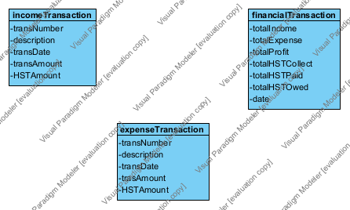

1. Income Transaction Query

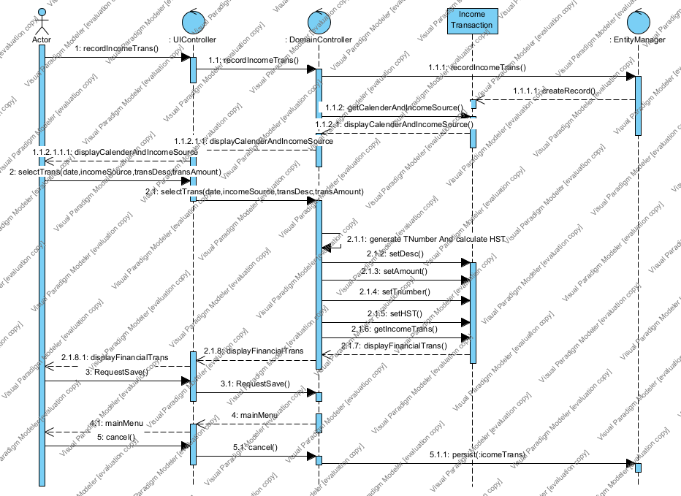

1. Expense transaction query

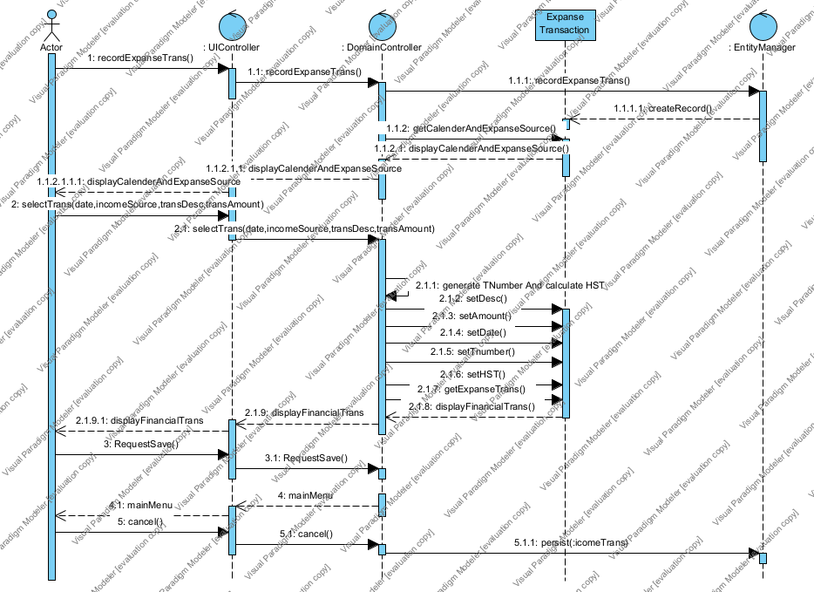

1. Financial Transaction Query

